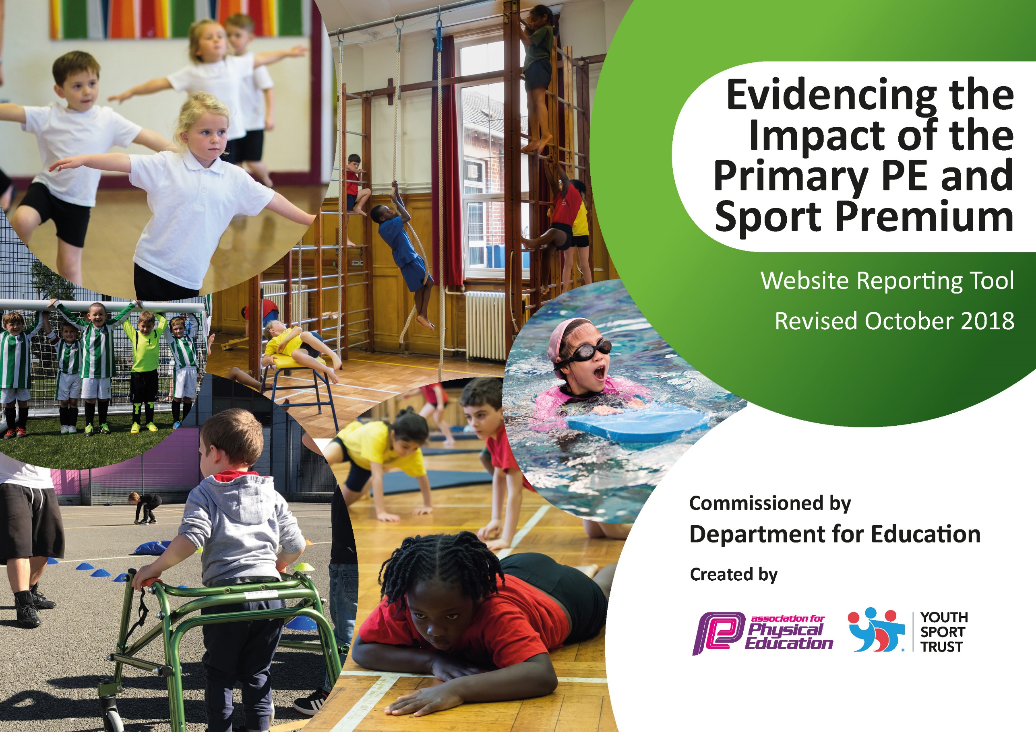
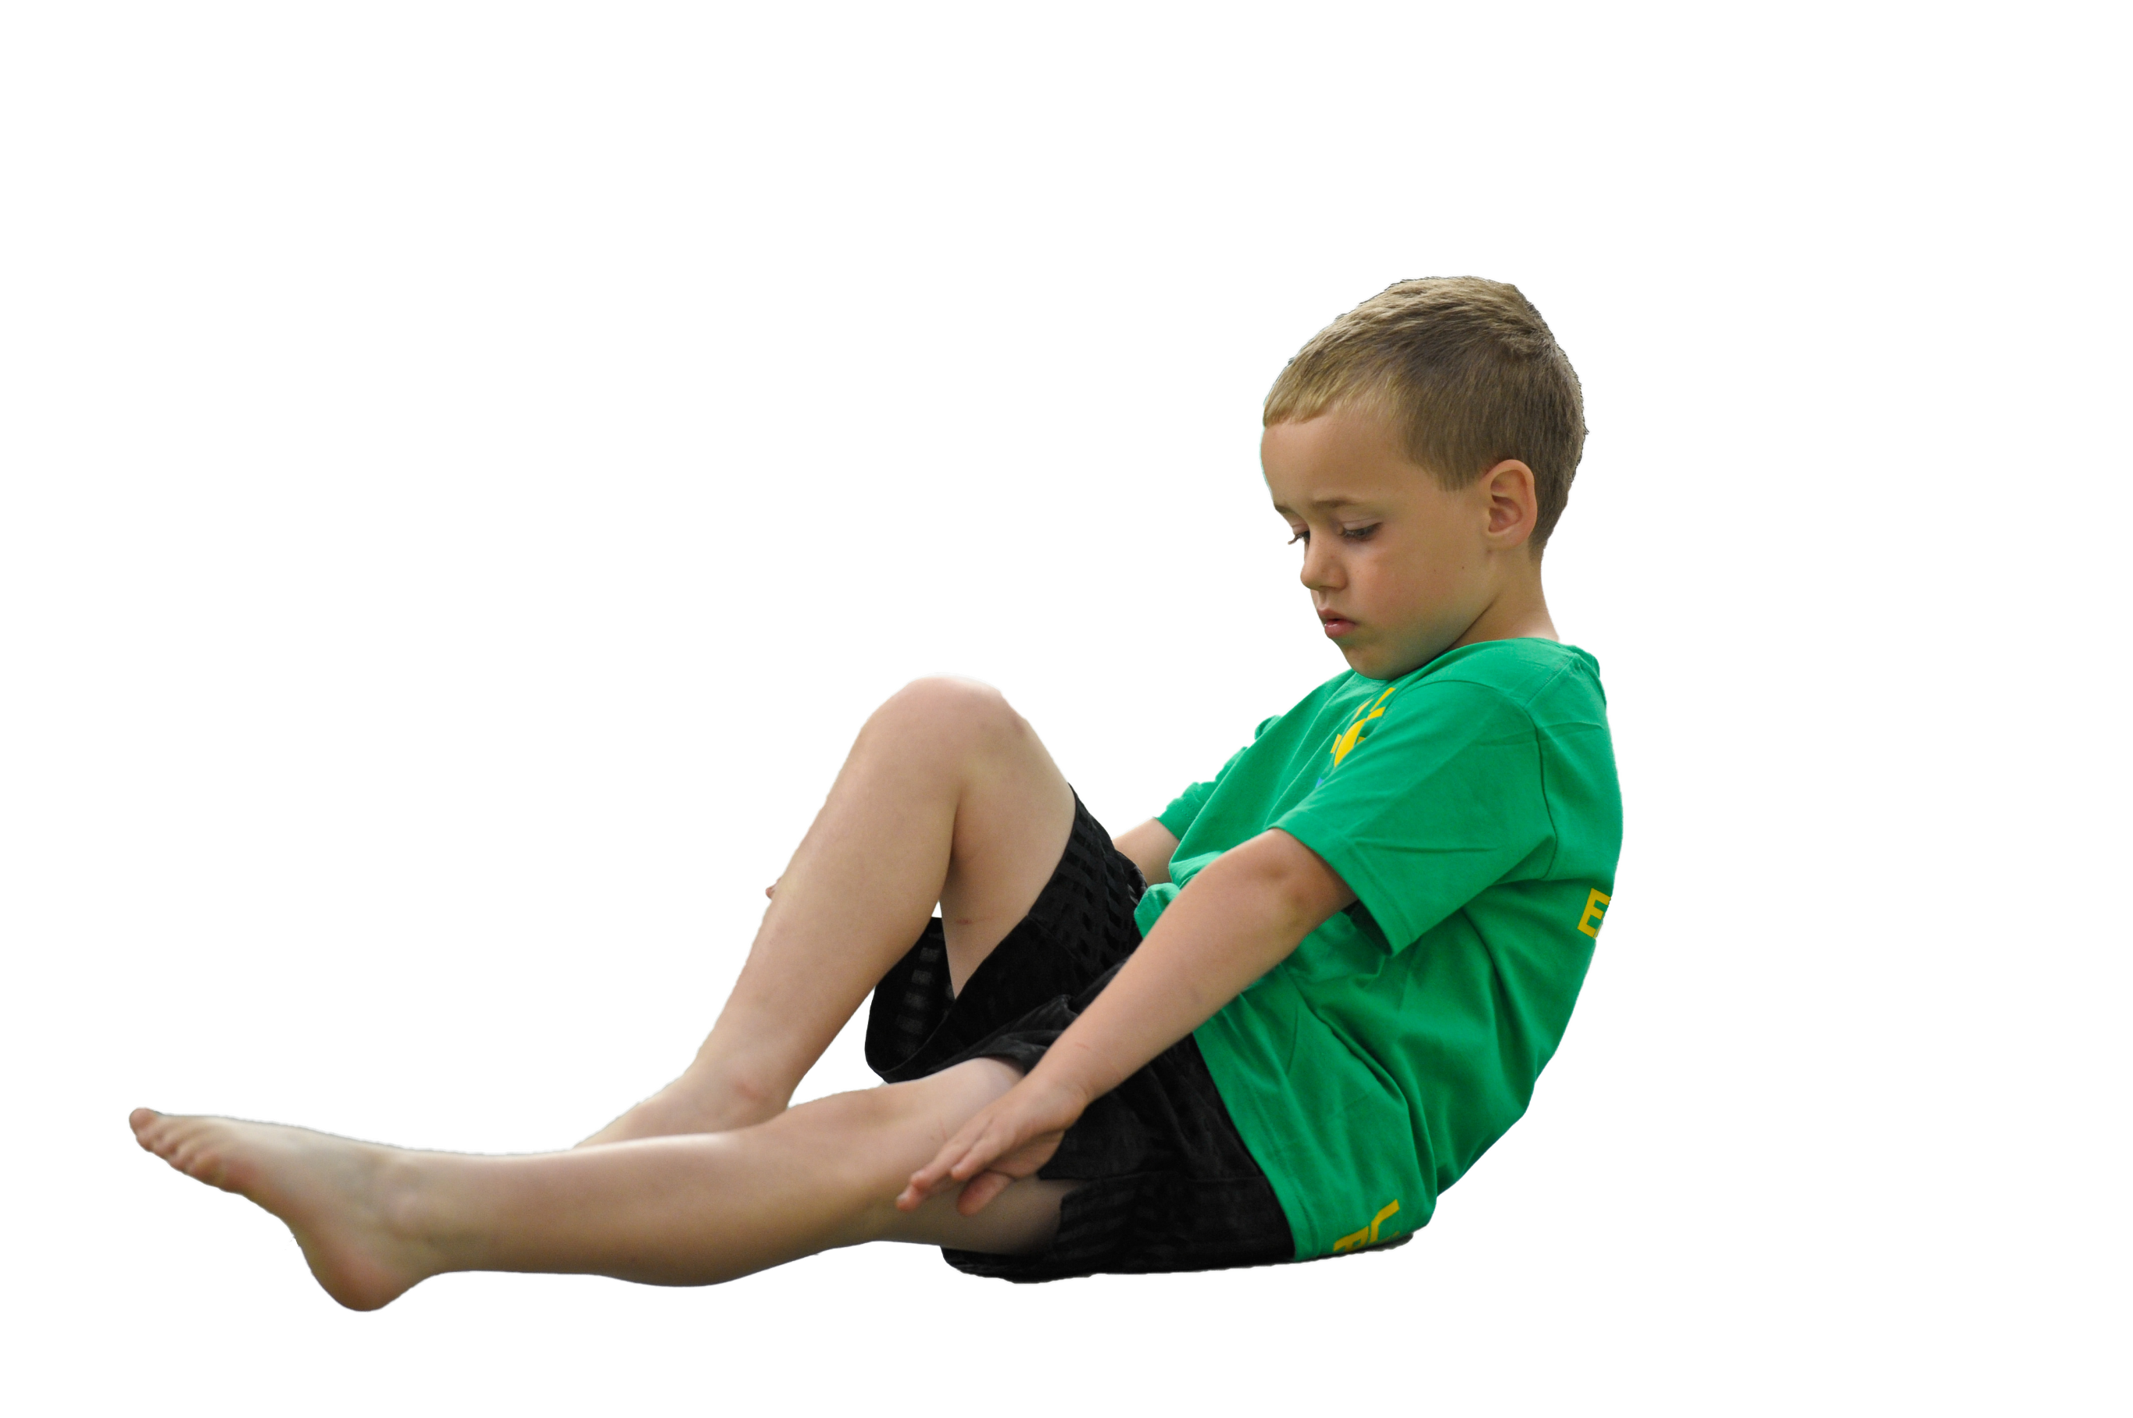
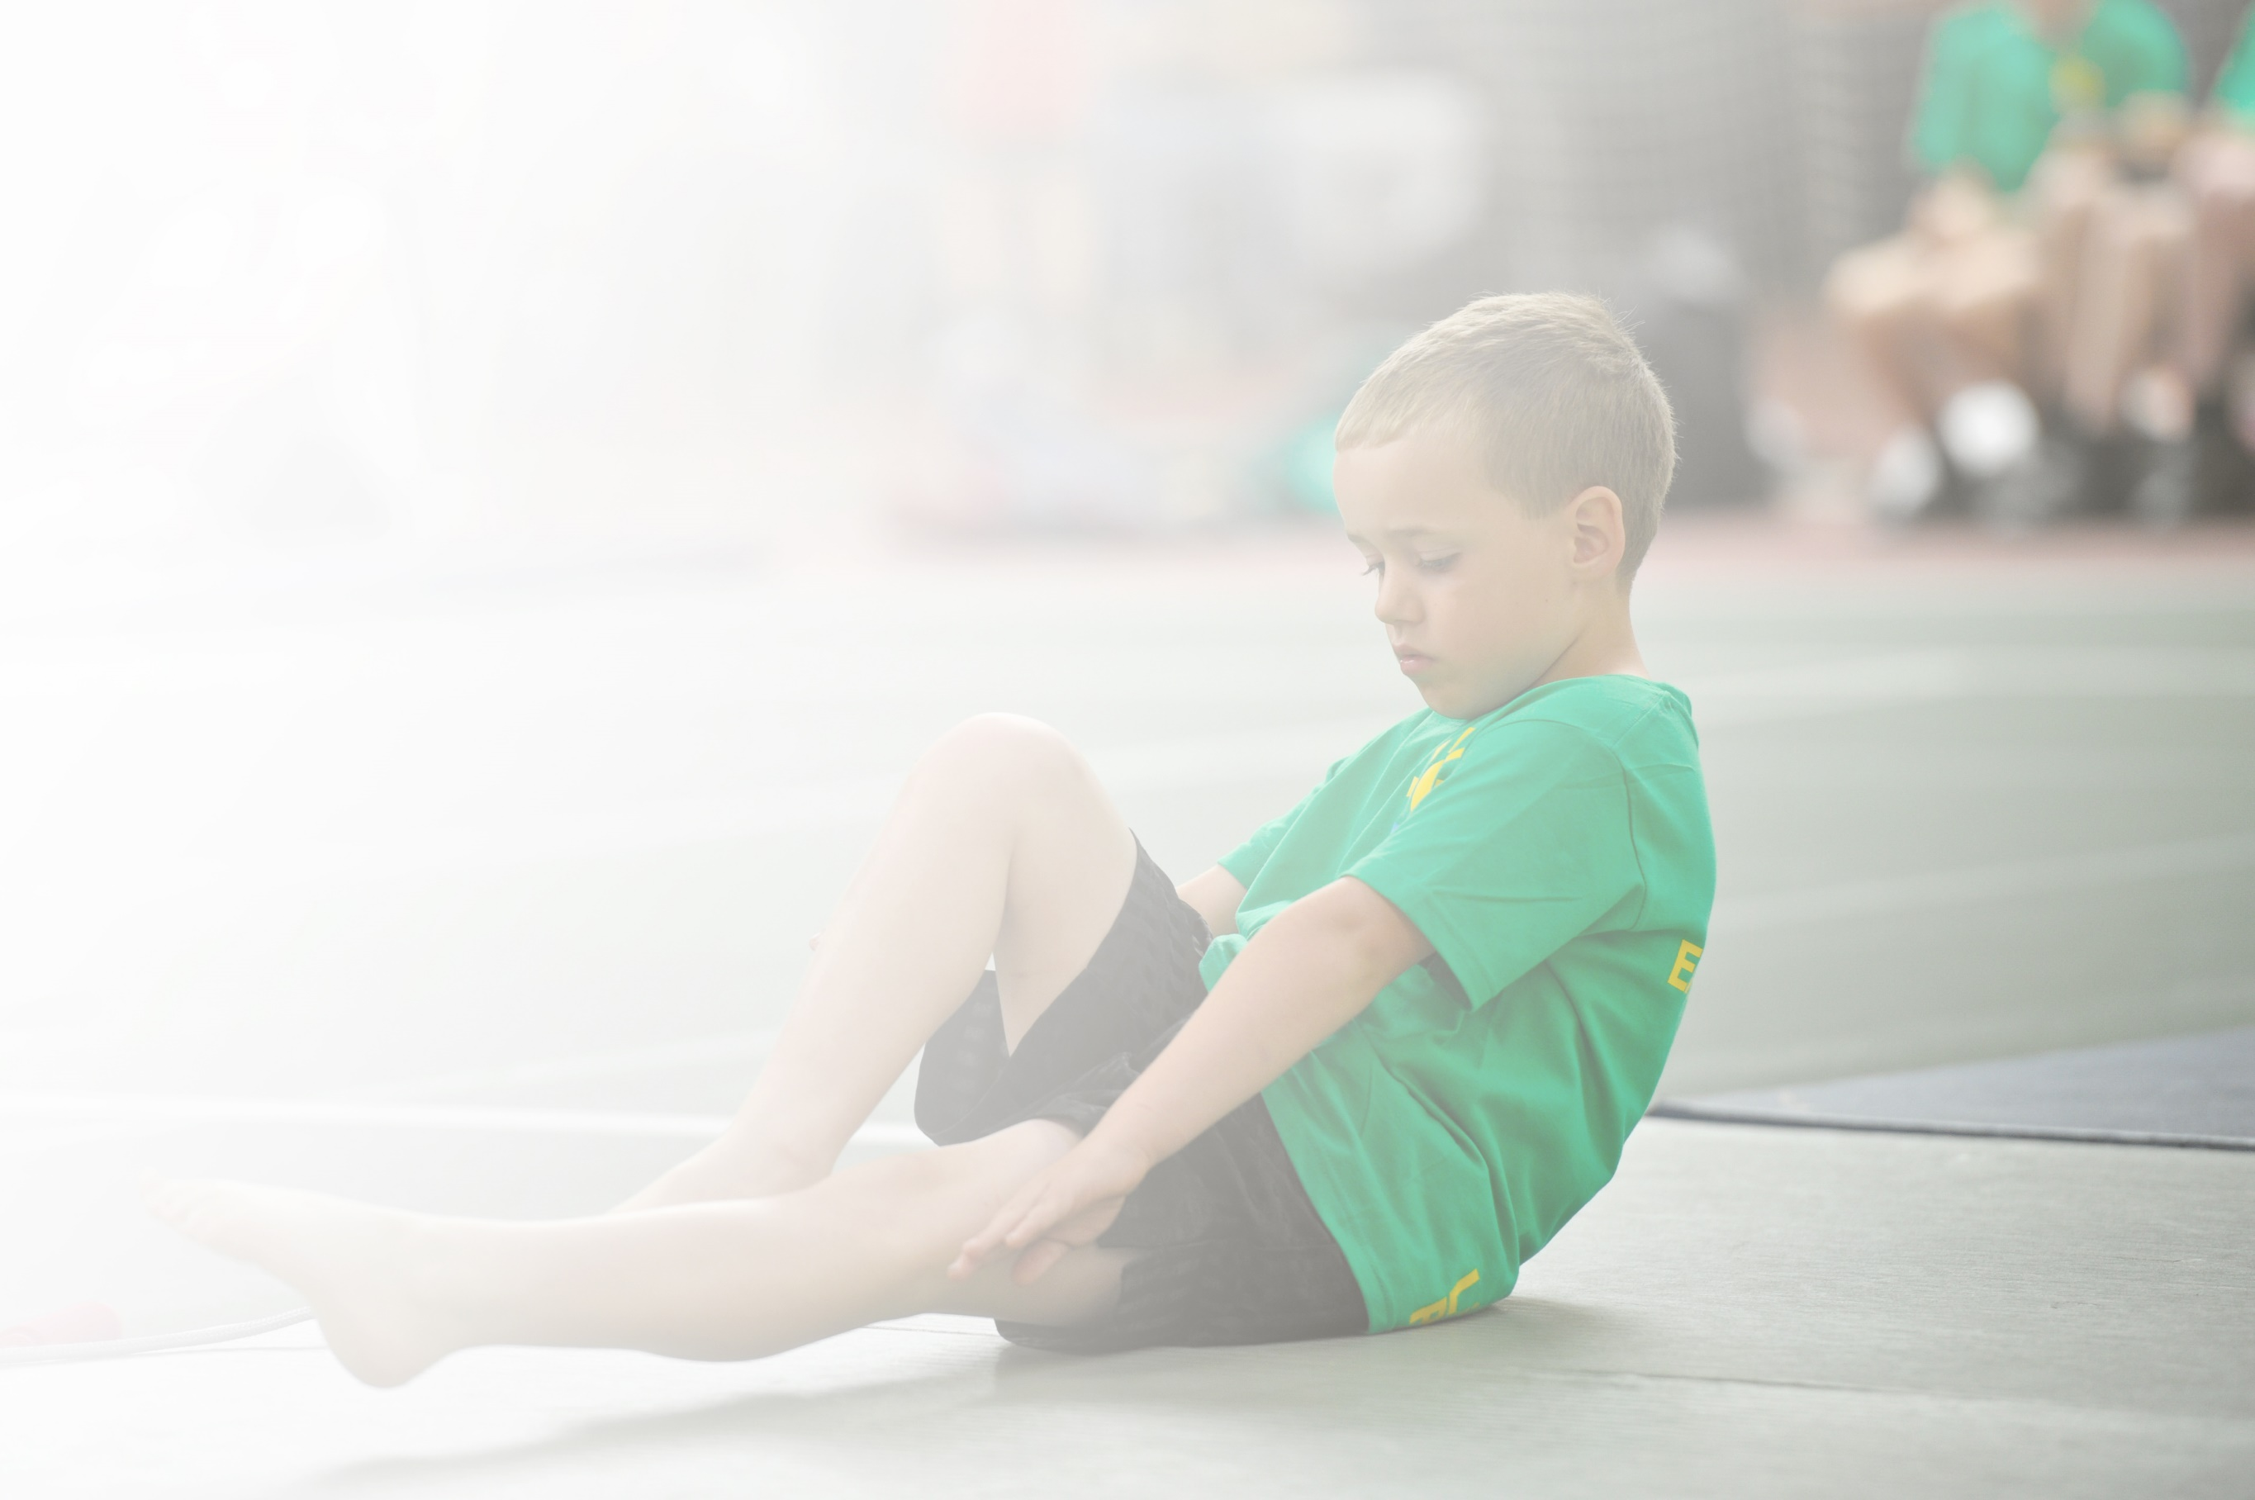
Schools must use the funding to make additional and sustainable improvements to the quality of Physical Education, Sport and Physical Activity (PESPA) they offer. This means that you should use the Primary PE and Sport Premium to:

- Develop or add to the PESPA activities that your school already offer
- Build capacity and capability within the school to ensure that improvements made now will benefit pupils joining the school in future years

Please visit gov.uk for the revised DfE guidance including the 5 key indicators across which schools should demonstrate an improvement. This document will help you to review your provision and to report
your spend. DfE encourages schools to use this template as an effective way of meeting the reporting requirements of the Primary PE and Sport Premium.

We recommend you start by reflecting on the impact of current provision and reviewing the previous
spend. Under the Ofsted Schools Inspection Framework, inspectors will assess how effectively leaders use the Primary PE and Sport Premium and measure its impact on outcomes for pupils, and how effectively governors hold them to account for this.

Schools are required to publish details of how they spend this funding as well as on the impact it has on pupils’ PE and sport participation and attainment by the end of the summer term or by 31 July 2019 at the
latest.
We recommend regularly updating the table and publishing it
on your website throughout the year, as evidence of your
ongoing review into how you are using the money to
secure maximum, sustainable impact. To see an
example of how to complete the table please
click HERE.

Support for review and reflection - considering the 5 key indicators from DfE, what development needs are a priority for your setting and your students now and why? Use the space below to reflect on previous spend, identify current need and priorities for the future.

Key achievements to date: | Areas for further improvement and baseline evidence of need:
- Identification of a PESPA leader for each centre  - Training for PESPA leaders  - Built in competition for pupils through Personal Best challenges  - Improvements to physical spaces and resources for physical activity  - Improved staff skills to use resources and deliver PE.  - Access to sports outside of traditional PE experiences through off site activities and specialist coaches eg street dance (Lancing), water sports (Burgess Hill), Circus skills (Chi)  - Weekly Boxing sessions for all pupils to help with discipline and coordination.  - Sports kit provided for most pupils  - Scooter skill development for all pupils. | - Equitable provision across all 3 APC sites  - Baseline assessment for pupils on entry.  - Engage and Sustain family engagement with healthy habits.  - Review activities with pupils and assess progress.  - Development of cycling provision  - Use of sport as a tool for whole school improvement  - Whole school sports events

Meeting national curriculum requirements for swimming and water safety | Please complete all of the below:
What percentage of your current Year 6 cohort swim competently, confidently and proficiently over a distance of at least 25 metres?  N.B. Even though your children may swim in another year please report on their attainment on leaving  primary school. | 33% (2 of 6 pupils)
What percentage of your current Year 6 cohort use a range of strokes effectively [for example, front crawl, backstroke and breaststroke]? | 17% (1 of 6 pupils)
What percentage of your current Year 6 cohort perform safe self-rescue in different water-based situations? | 0% (0 of 6 pupils)
Schools can choose to use the Primary PE and Sport Premium to provide additional provision for swimming but this must be for activity over and above the national curriculum requirements. Have you used it in this way? | No

1

Academic Year: 2018/19 | Total fund allocated: £28,090 | Date Updated: Jan 2020
Key indicator 1: The engagement of all pupils in regular physical activity – Chief Medical Officer guidelines recommend that primary school children undertake at least 30 minutes of physical activity a day in school |  |  |  | Percentage of total allocation:
 |  |  |  | 26%
School focus with clarity on intended impact on pupils: | Actions to achieve: | Funding allocated: | Evidence and impact: | Sustainability and suggested next steps:
- All pupils have the personal equipment to access sport.  - Offer a range of sports activities at playtimes and via the curriculum. | - Kit, bags and water bottles to be made available for all children  - Upgraded equipment. | £7350
Key indicator 2: The profile of PESSPA being raised across the school as a tool for whole school improvement |  |  |  | Percentage of total allocation:
 |  |  |  | 12%
School focus with clarity on intended impact on pupils: | Actions to achieve: | Funding allocated: | Evidence and impact: | Sustainability and suggested next steps:
- All pupils benefit from cross curricular sport to develop skills for life, literacy and numeracy.  - Pupils to start to gain an understanding of Healthy eating/cooking in order to get a healthy balanced diet.  - Sport promoted as part of a healthy life style with families | - Albion in the Community Project  - Planning and resourcing  - Compass Cards to be signposted to all parents. | £3335

Key indicator 3: Increased confidence, knowledge and skills of all staff in teaching PE and sport |  |  |  | Percentage of total allocation:
 |  |  |  | 9%
School focus with clarity on intended  impact on pupils: | Actions to achieve: | Funding  allocated: | Evidence and impact: | Sustainability and suggested  next steps:
- Development of cycling skills provision for all pupils  - Staff act as role models in sport and are increasingly delivering sport activities in-house.  - Staff have access to a wide range of documentation to assist with planning | - Work with Wes Sussex Cycling Development Team to develop provision. This will include purchasing equipment and storage, initial provision of courses from West Sussex and training for key staff.  - Staff participate in sessions delivered by external providers.  - Staff lead/deliver/assist sports activities.  - Shared resource area on Sharepoint. | £2350
Key indicator 4: Broader experience of a range of sports and activities offered to all pupils |  |  |  | Percentage of total allocation:
 |  |  |  | 43%
School focus with clarity on intended  impact on pupils: | Actions to achieve: | Funding  allocated: | Evidence and impact: | Sustainability and suggested  next steps:
- All pupils to experience at least 3 non-traditional sports through the use of internal and external experiences. | - Specialist activities Non-traditional sports to include –  Circus Skills  Water Sports  Adventurous Activities  Cycling  Scootering  Dance | £12,130
Key indicator 5: Increased participation in competitive sport |  |  |  | Percentage of total allocation:
 |  |  |  | 4%
School focus with clarity on intended  impact on pupils: | Actions to achieve: | Funding  allocated: | Evidence and impact: | Sustainability and suggested  next steps:
- All pupils to experience competitive sport | - Whole School Personal Best Challenges  - Whole School Sports day. | £1000

